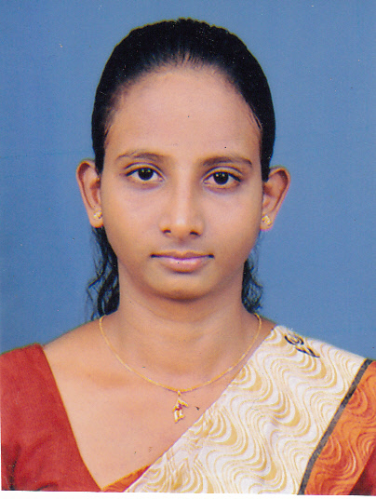

**CURRICULUM VITAE**

**Harshani Nilusha Thalagala**

[**nilushahashi@gmail.com**](mailto:%20%20%20%20%20%20%20%20%20%20%20nilushahashi@gmail.com)

***PERSONAL DETAILS***

Name in Full : Harshani Nilusha Thalagala

Name With Initials : H.N. Thalagala

Address : No: 56/C, Chithra Lane, Colombo 05.

Date of Birth : 1991.04.09

NIC No. : 916000197V

Gender : Female

Civil Status : Single

Nationality : Sri Lankan

Contact Numbers : Mobile – 0776445161 / 0772572315

***EDUCATIONAL QUALIFICATIONS***

* Passed G. C. E. (A/L) Examination in 2010, (Sinhala Medium), at Sirimavo Bandaranaike Vidyalaya - Colombo 07.

**Subject Grade**

Business Studies C

Economics S

Accounting S

General English C

* Passed G. C. E. (O/L) Examination in 2007 (Sinhala Medium), at Sirimavo Bandaranaike Vidyalaya - Colombo 07.

**Subject Grade**

English A

Religion A

Eastern Music A

Science B

Mathematics B

Sinhala B

Social Studies B

Health B

Commerce C

Development Studies C

***PROFESSIONAL QUALIFICATIONS***

* I have followed National Certificate in Information & Communication Technology Full-Time Course (NVQ Level 4) at National Apprentice and Industrial Training Authority (NAITA), Colombo District Office , Havelock Town, Colombo 05. (6 Months)
* I have followed Certificate Course in English Language (Intermediate Level and Higher Level) conducted by Institute of Human Resource Advancement -University of Colombo. (12 months)
* Currently I am following Certificate Course in Spoken English conducting by Institute of Human Resource Advancement -University of Colombo. (6 months)

*WORK EXPERIENCE*

* I have worked as a Trainee Banking Assistant at Bank of Ceylon, Bambalapitiya. (6 months)
* Also I have worked as a Word Processing Assistant at Department of International Relations, University of Colombo. ( 11 months)
* I have worked as a Trainee Assistant at Research and Management Unit, College House, University of Colombo.
* I have worked as an Operations Executive at American Premium Water (Pvt) Ltd, Sri Sangaraja Mawatha, Colombo 10. (5 months)

*SKILLS*

* Typing skills in both Sinhala and English language.
* Very good knowledge in using MS Office Tools.
* Both skills utilized for work at the Department of International Relations in preparing power points presentations,

typing research paper for senior academics.

* Experienced in work at the Research and Management Unit by preparing statements, handling Budgets related to the Extension Courses and relevant Funds of Departments related to the Faculty of Arts.

***EXTRA QUALIFICATIONS***

* Secretary of the School Consumer Circle.
* Member of the School Commerce Society.
* Active Member of the School Ran Kekulu Sansandaya conducted by Bank of Ceylon.
* I have taken part in School Athletics.
* Member of School Eastern Band.
* Prefect of the Dhamma School, Sri Saranapala Temple, Colombo – 05.

***NON - RELATED REFEREES***

Mrs. Hetti Kankanange Dilani Kaushali Mrs. Pradeepika Samarawickrama

Attorney-at-Law Physical Officer

No:761, Thalangama Town No: 150, TharakaSewana

Battaramulla. Homagama.

[dkaushi@sltnet.lk](mailto:dkaushi@sltnet.lk) Kiriwattuduwa,

011-2784734 011-2754204

I do hereby certify that above mentioned details are true and correct to the best of my knowledge.

**Date Signature of Applicant**